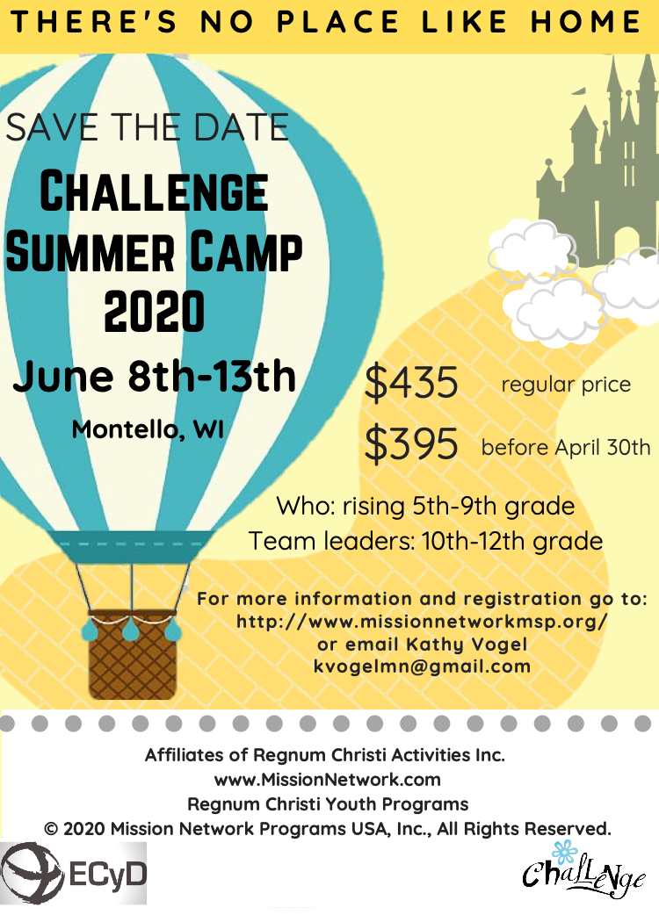

Registration Packet

Challenge Summer Camp
2020

This packet includes:

Camper Registration Checklist

Volunteer Information & Volunteer Form

All camper forms
Camper Registration Checklist
All forms and a min of $100 of the camp payment must be sent in by June 1st, in order to secure a spot. The remainder of your payment may be given upon arrival.

NO CAMPER IS ALLOWED TO ATTEND CAMP WITHOUT ALL FORMS COMPLETED

- Payment
- Registration Form
- Permission to Participate Form
- Medical Form
- Copy of Medical Insurance Card
- Please pay and register online or send payment and forms to
Challenge Summer Camp
Attn: Kathy Vogel
7815 Victoria Dr.
Victoria MN, 55386

Volunteer Information
Challenge Summer Camp welcomes those who would like to volunteer. Please let us know if you would like to help out this year!

What are the Requirements of a Chaperone?
- Chaperones must provide a copy of their VIRTUS training certificate.
- Chaperones must comply with all other Diocesan Requirements for the diocese you are residing in.
- Chaperones must complete volunteer training with Mission Network: https://www.missionnetwork.com/volunteers
- Please email Kathy Vogel kvogelmn@gmail.com, if you have any questions.

What does a Chaperone do?
- Supervise activities when needed
- Set up crafts and activities before they begin
- Clean up from activities and keep areas organized when needed
- First Aid, photography, errands
- Supervise bedtime and wake up.
- Be the prayer warriors for all the campers and camp leaders!
- There will be daily gospel reflections offered for Chaperones, and one morning of reflection. Our Chaplin will also be available for confession and spiritual guidance for those who are interested.

What is the Cost?
Challenge camp does not charge Chaperones.
However, the actual cost of volunteers for food, lodging and insurance is $250, therefore any donations to help cover this cost are gratefully accepted.

What are the sleeping arrangements for summer camp?
Chaperones will sleep in bunkrooms in order to chaperone campers, and eat meals with the campers. Complementary coffee and tea are available in the main lodge day and night.

I would like to volunteer! What do I do?
Please fill out the attached Volunteer Form
Send the form and certificates to:
Camp Volunteer 2019
7815 Victoria Dr.
Victoria MN, 55386

Chicagoland Challenge Camp 2020
Registration Form
IMPORTANT: Registration form must be completed with a minimum of $100 of the camp’s full payment to secure a spot.

Make Checks Payable to: Mission Network Minneapolis St. Paul

Send Registration and Payment to**:
Challenge Camp 2020
Attn: Kathy Vogel
7815 Victoria Dr.
Victoria MN, 55386

Child’s Full Name: ___________________________
DOB: ________ Grade for next school year (2020-2021): ______
Shirt Size : Youth M, Youth L, Adult S, Adult M, Adult L, Adult XL (Circle one)
Father’s Name: _____________________________

Mother’s Name: _____________________________

Parent’s Email: _____________________________
Parent’s Phone Number: _____________________

Home Address: _______________________________________________

__________________________________________________________

Cancellation Policy: Until June 1st, there is a $50 cancelation fee. After June 1st, the full registration is NOT refundable.
Payments may be done online or by mailing a check. This registration form may be mailed or emailed to kvogelmn@gmail.com

For questions please contact Kathy Vogel
kvogelmn@gmail.com
763-245-8957

PERMISSION TO PARTICIPATE IN ACTIVITIES
2020
MISSION NETWORK ACTIVITIES USA, INC.
For Participates UNDER 18 Years Old
THIS FORM IS TWO PAGES

- CHILD'S NAME:____________________________________________________________________ CHILD’S BIRTHDATE: _________________

- NATURE AND DURATION OF ACTIVITIES: June 8th-13th. Swimming, horseback riding, canoeing, sports and relays, team building, water games, hiking, Archery, mentoring, mass, prayers and conferences.
- ACTIVITY SUPERVISOR(S): , Siena Schmitz, and Fr. Chad Everts and approved RC Activities Parent Chaperones.
- MENTORING: Participants may be offered mentoring, which is intended to help young people personalize the principles of Christian living that they receive at home. Mentoring is a private conversation with an adult conducted in plain view of others. When dealing with adolescents, confidentiality will be maintained to foster openness of dialogue, but situations involving sexual abuse of a minor or threats to life, physical health etc. will be reported to the appropriate authority and to the parents (except in those cases where the parent may be the alleged abuser).
- REQUIREMENTS: The child named above is in good health and has no physical or medical limitations that would cause the activities as described above to be detrimental or dangerous to the child. Parents/guardians should specify allergies/medical problems in the medical record form.
- CONSENT: I/We hereby consent to the above-named child's participation in the activities described above, and specifically request that she be allowed to participate in those activities. I/We warrant that I/We have full authority to legally consent to her participation in the activities described on this form, and all provisions contained herein.
- AUTHORIZATION: I/We hereby authorize RC Activities, Inc. to use the image and likeness of my/our child in photograph or video form whether taken by or commissioned by RC Activities, Inc. in its promotional materials and for its promotional purposes associated with its nonprofit activities. This authorization shall extend to use of my/our child’s image and likeness on the website of RC Activities, Inc., or its successor in operation or affiliated organization(s) upon written consent of RC Activities, Inc. I/We understand that this authorization shall survive the end of my/our child’s participation in the activities referenced on this form.
- INSURANCE: I/We understand that RC Activities, Inc. does not carry any health insurance relative to the activities or for any injury that may occur to the above-named child. I/We represent that the child is (a) covered by insurance through my/our own insurance carrier; (b) that I/We am/are personally financially responsible for any and all medical costs incurred as a result of the child's injury.
- EMERGENCIES: If the above-named child requires any emergency medical procedures or treatments during the activities, I/We consent to the activity supervisor(s) taking, arranging for or consenting to such procedures or treatments in the discretion of the activity supervisor(s). For purposes of such procedures & treatments, I/we have completed the medical information form for the above named child.
- EMERGENCY CONTACTS: If, in the event of a medical or other emergency, I/We am/are unable to be reached by telephone at the numbers listed below, I/We authorize the activity supervisor(s) to attempt to contact me/us through the alternative emergency contacts listed below.

Parents/ Guardians Contact Information (If a guardian, please specify relationship.)

Father’s Name: ___________________________________________ Father’s Number: _________________________________________

Father’s Email: ___________________________________________ Father’s Alternative number: ________________________________

Home Address: ________________________________________________________________________________________________________

Mother’s Name: ___________________________________________ Mother’s Number: _________________________________________

Mother’s Email: ___________________________________________ Mother’s Alternative number: ________________________________

Home Address: ________________________________________________________________________________________________________
(If different from Father’s)

Alternative Emergency Contact Information (Please list AT LEAST ONE alternative contact.)

Name: _________________________________________________ Cell Number: ____________________________________________

Relation: _______________________________________________ Alternative number: _______________________________________

Name: _________________________________________________ Cell Number: ____________________________________________

Relation: _______________________________________________ Alternative number: _______________________________________

Form continues to next page

- RELEASE AND INDEMNIFICATION: I/We release and waive, and further agree to indemnify, hold harmless or reimburse RC Activities, Inc. and Consolidated Catholic Administrative Services, Inc., the individual members, agents, directors, officers, employees, volunteers and representatives thereof, as well as activity supervisors, from and against, any claim which I, any other parent or guardian, any sibling, the above-named child, or any other person, firm or corporation may have or claim to have, known or unknown, directly or indirectly, for any losses (including attorneys’ fees incurred by RC Activities, Inc. and Consolidated Catholic Administrative Services, Inc., or any of its individual employees, agents, volunteers, etc. in enforcing this indemnity provision) without limitation in time or amount, damages or injuries arising out of, during, or in connection with my/our child's participation in the activities, the travel to and there from, and the rendering of emergency medical procedures or treatment, if any. I/We understand that this release and indemnification shall survive the end of my/our child’s participation in the activities referenced on this form and shall have no limitation in time or amount.

I/We have read and understand the above and agree to all terms and conditions contained therein.

DATE: __________________________________

_____________________________________________________ _________________________________________________
Parent / Guardian Signature Parent / Guardian Signature

_____________________________________________________ _________________________________________________
Parent / Guardian Name (Please Print) Parent / Guardian Name (Please Print)

Medical Record
For RC ACtivities: Challenge Summer Camp 2020
June 8th-13th

__________________________ __________________________ _________
Name Last name M Initial

________________ ______________ lbs. _______________
DOB Weight Height

Insurance Information:

Name of Doctor: _________________________________________________________________________

City/State/Country: ______________________________________________________________________

Insurance Provider: _______________________________________________________________________

Insurance Policy Number: ________________________ Phone Number: ________________________

Copy of Insurance card attached
- Yes
- No

Medical Information:

Medicine Allergies: __________________________________________________________________________________________________________________________________________________________________________________________________________________________________________________________________________________________________________________________________________________________

Food Allergies: (please remember to send any special food items with your daughter)
*If Gluten or Dairy free, please send an additional $20 for added fees
____________________________________________________________________________________________________________________________________________________________________________________________________________________________________________________________________________

Blood type: _______________ Date of last tetanus vaccine: _______________________________

Is your daughter currently taking any medications?
- No
- Yes:
Type of Medication:___________________________________________
For:_______________________________________________________
Dose:______________________________________________________
Has your daughter had any major surgeries?
- No
- Yes: _____________________________________ Date: ____________

Has your daughter been in an accident or hospitalized in the last few years?
- No
- Yes. Details: ________________________________________________________________________________________________________

Please mark any illnesses, symptoms or allergies your daughter has:

- Frequent stomach Pains  - Digestive problems  - Eating disorder  - Rheumatic fever  - Urinary infection  - Emotional Disorder  - Measles  - Sensitivity to Sun  - Asthma  - Fainting | - Ear Infection  - Sleepwalking  - Rubella  - Convulsions  - Bronchitis  - Chicken Pox  - Impetigo  - Hepatitis  - Frequent chills | - Sinusitis  - Epilepsy  - Hernia  - Diabetes  - Heart problems  - Migraines  - Kidney Infections  - Anemia

Notes: __________________________________________________________________________________________
____________________________________________________________________________________________________________________________________________________________________________________________________________________________________________________________________________________________________________________

Volunteer Form
Challenge Summer Camp
June 8th-13th, 2020
Please Print Information Clearly

______________________________ _______________________________ __________________
First Name Last Name DOB

______________________________ __________________________________________________________
Phone Number Email

_________________________________________________________________________________________________
Mailing Address City State/Zip

What is your diocese? ________________________________________

Do you know what other requirements are given by your diocese to comply with child protection?
Y Please Specify requirements:

N If no, please look it up on your diocesan website before attending camp.

Do you have a daughter attending camp? Y N
If yes, what is your daughter’s name and grade:___________________________________________________

Have you volunteered for camp in the past? Y N

Are you an RN? Y N

Please mark how you would like to help out this year:
- Help on day of set up and registration
- Chaperone the whole week (June 8th-13th)
- Chaperone for part of the week. Please specify dates: _____________________________________________
- I am unable to help during the camp but please contact me if you need help with preparation or materials for camp.

THE FOLLOWING IS LEGALLY REQUIRED FOR YOU TO VOLUNTEER:

Have you taken Virtus training?
- Yes, I am including a copy of my certificate with this form
- No, but I will complete it by camp and bring a copy of my certificate to camp

Have you been trained as Mission Network Volunteer?
- Yes, I am including a copy of this certificate with this form
- No, but I will complete it by camp and bring a copy of my certificate to camp

Send form to: CAMP VOLUNTEER 2020. 7815 Victoria Dr. Victoria MN, 55386.
Must Send by: April 30th 2020

